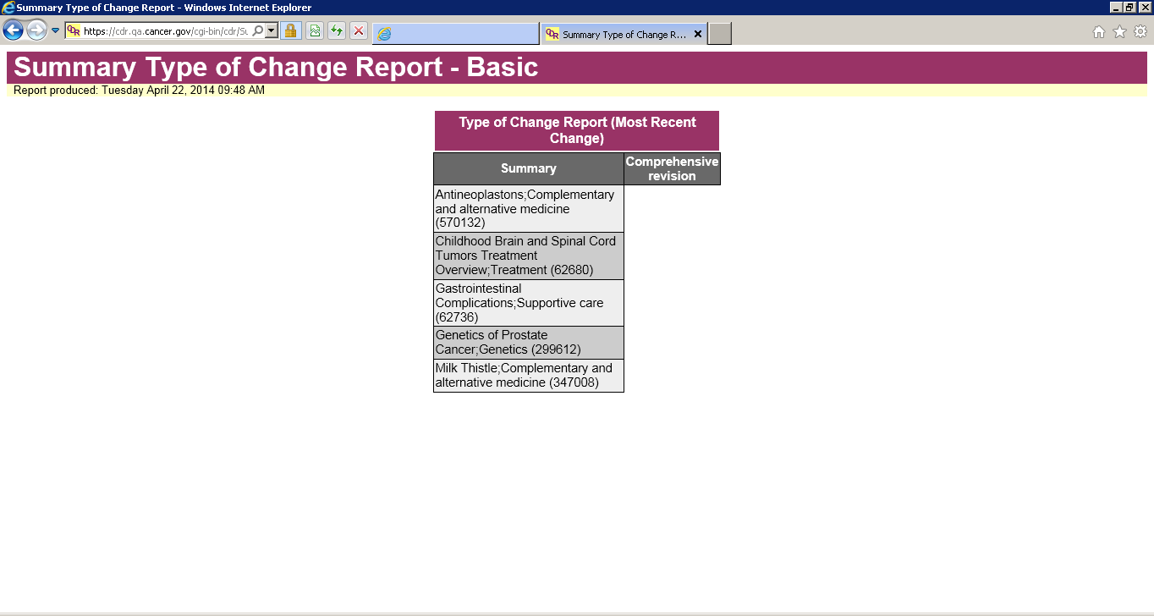
Selected Options: Web page, HP, All English, Comprehensive Revision (no comments)

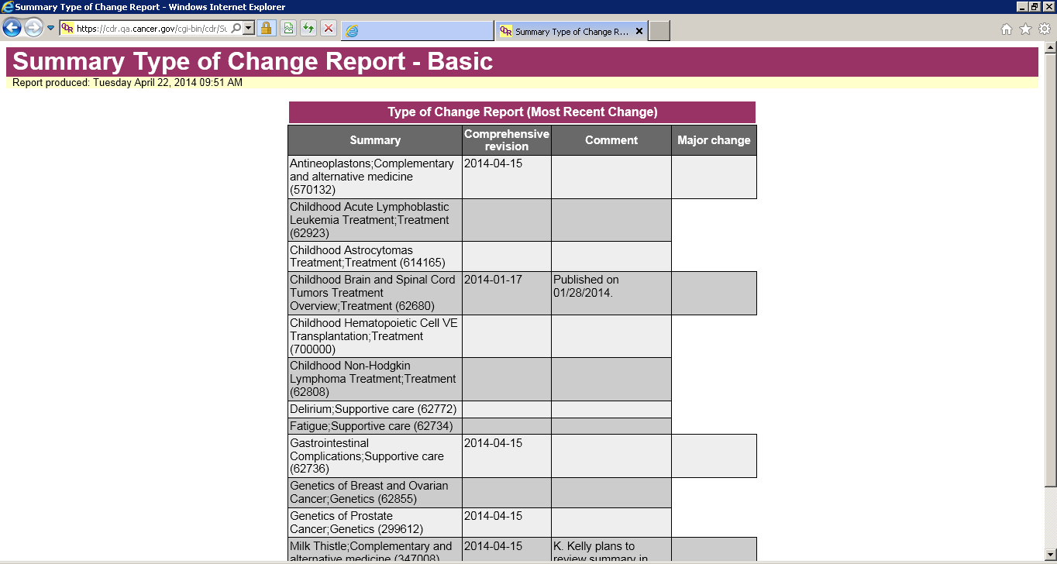
Selected options: Web page, HP, All English, Comp Rev, Comp Rev Comments, Major Change

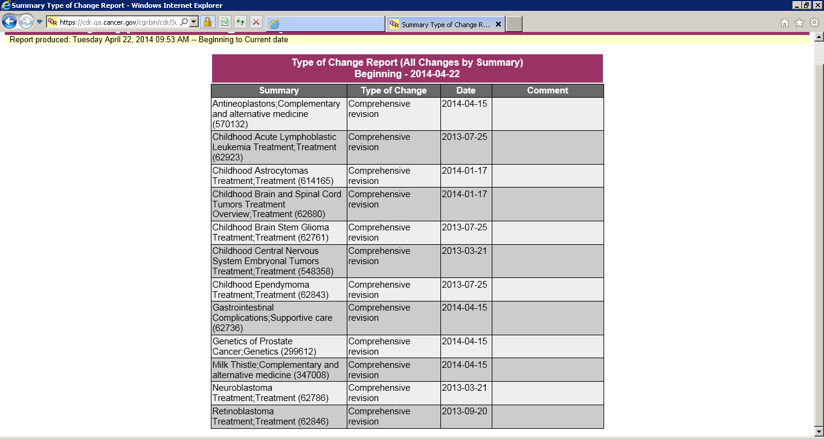
Selected options: Web page, HP, All English, Comprehensive Revision (no comments), Advanced Report by Summary – Comments column should not display.

